

Tuesday, September 05, 2006

To whom it may concern;

This is a letter of recommendation for Jamie Parisi and his company Parisi Computers. We got to know Jamie during his time with another computer service firm. He had looked after the installation, networking and trouble shooting for our two new computers. As well, he expertly worked with our major funeral home software developer to make sure the integration of our new system and the software was seamless.

His work with us has also included the recommendation and support in selecting of other computers (laptops) for personal and corporate use. His help has been invaluable in problems working with our web support team and our internet supplier.

Personally, he is a very patient man, someone who is important to us in the work he does. We have worked with other IT people who have given us attitude over our lack of knowledge. This has never happened with Jamie. I highly recommend both he and his company. On a number of occasions, he has been there at a moments notice when these crisis’ in our computer life occurs. I would suggest that you allow Jamie to show you his ability.

Respectfully,

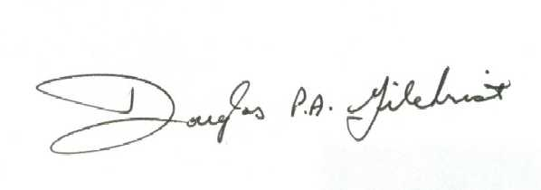
President

